Institute of Grace November 2017 Newsletter
School Enrollment is up! There are now 183 children attending EGF.
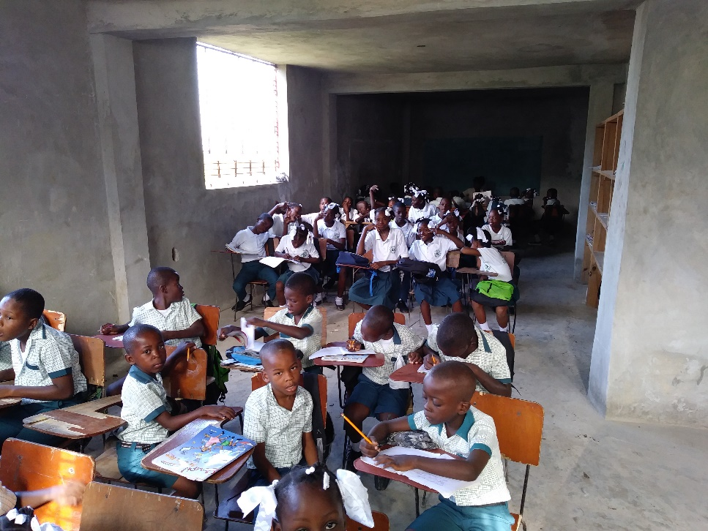
The additional classroom space in the bottom floor of the building has allowed us to get more children off the streets and into classes. Food costs have obviously increased so we are praying for more sponsors of the daily feeding program. We are looking at dividing walls for the bottom floor as they have four classes meeting without dividers. Because of your support for EGF, children are getting an education. You can be part of changing their lives.
Three classes on one side of the lowest floor. Room dividers will help them concentrate on their studies.

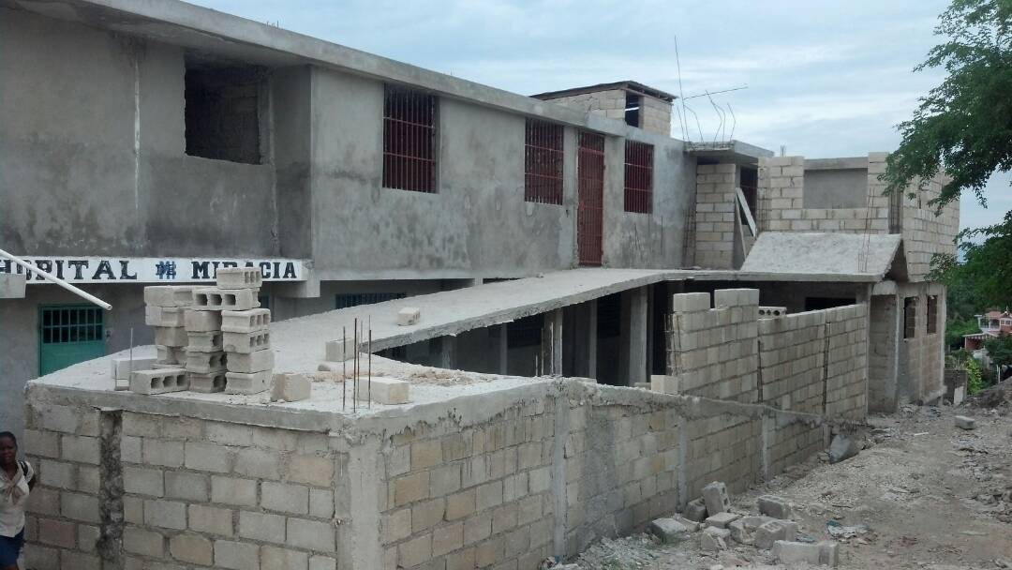
The new cistern has been covered, a ramp has been built to the third floor and security walls are going up. This is a major step forward in preparing the main building for medical uses. I had a great conversation with Dr. Fabriola and Dr. Tony about their plans for the hospital.

David Graves installed the shelves and wiring for two solar panels on his trip in November. Unfortunately, the cages were secured on the wrong corner of the roof, so I could not complete the connections, but we now have everything on site for solar power to the computer lab.
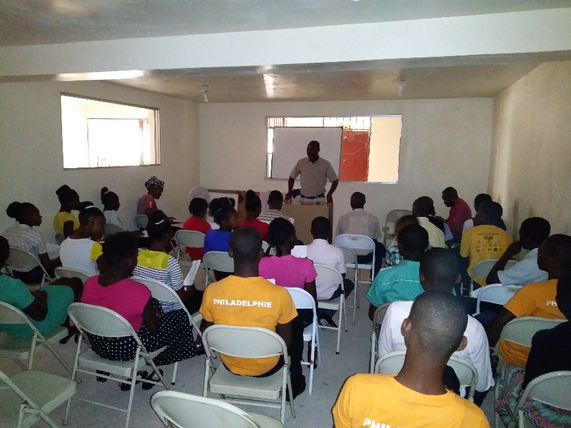
I was able to finish unloading the Red Church Bus and we used it to transport 40 students from Leogane to Merger for two days of classes which David Graves led on Friday and Saturday, November 3 - 4. Shipping supplies and vehicles is always a challenge, so we praise God for the new bus and the opportunities it provides.

Jean Filostin talking with the group from Leogane. It was their first time working with us.
Contributions can be sent to:

Institute of Grace
P.O. Box 2364
Leesburg, VA 20177

Or contact David Graves for information about setting up a direct contribution.
The IOG employs Haitians in the local communities, making all this possible. Without contributions from the United States, the school and university would not be able to reach all the students, so funding is a critical component of this ministry.

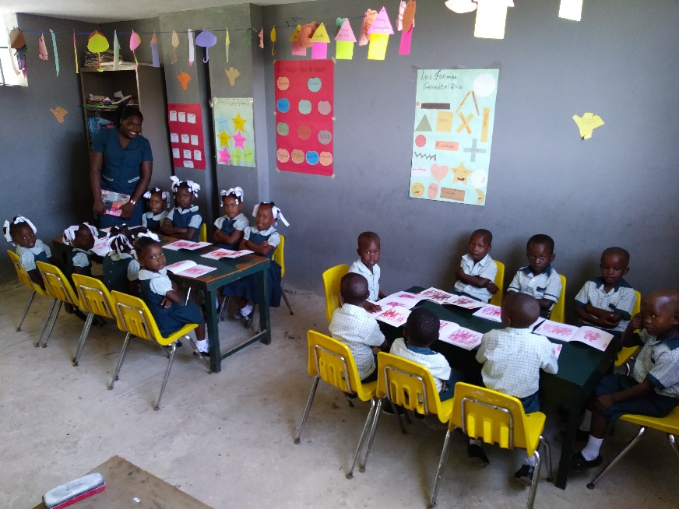
Back in school for another year.
Other news bullets:
- Pray for the University as the leaders plan for next year.
- Pray for Jean while he is in Haiti, that God will bless his efforts.
- Now is the time to be planning for 2018 teams. I’d love to settle on dates so that I can advertise the trip amongst all the IOG supporters.
Thanks for your prayers and support!
David Graves 240 601 0218 davidgraves1982@gmail.com

